Dear Sponsor,

I am writing you concerning a sponsorship opportunity with the 2018 College Exploration Trip. I know that you have a desire to give back to the local community and we would greatly appreciate your support in helping us to reaching our $20,000.00 fundraising goal.
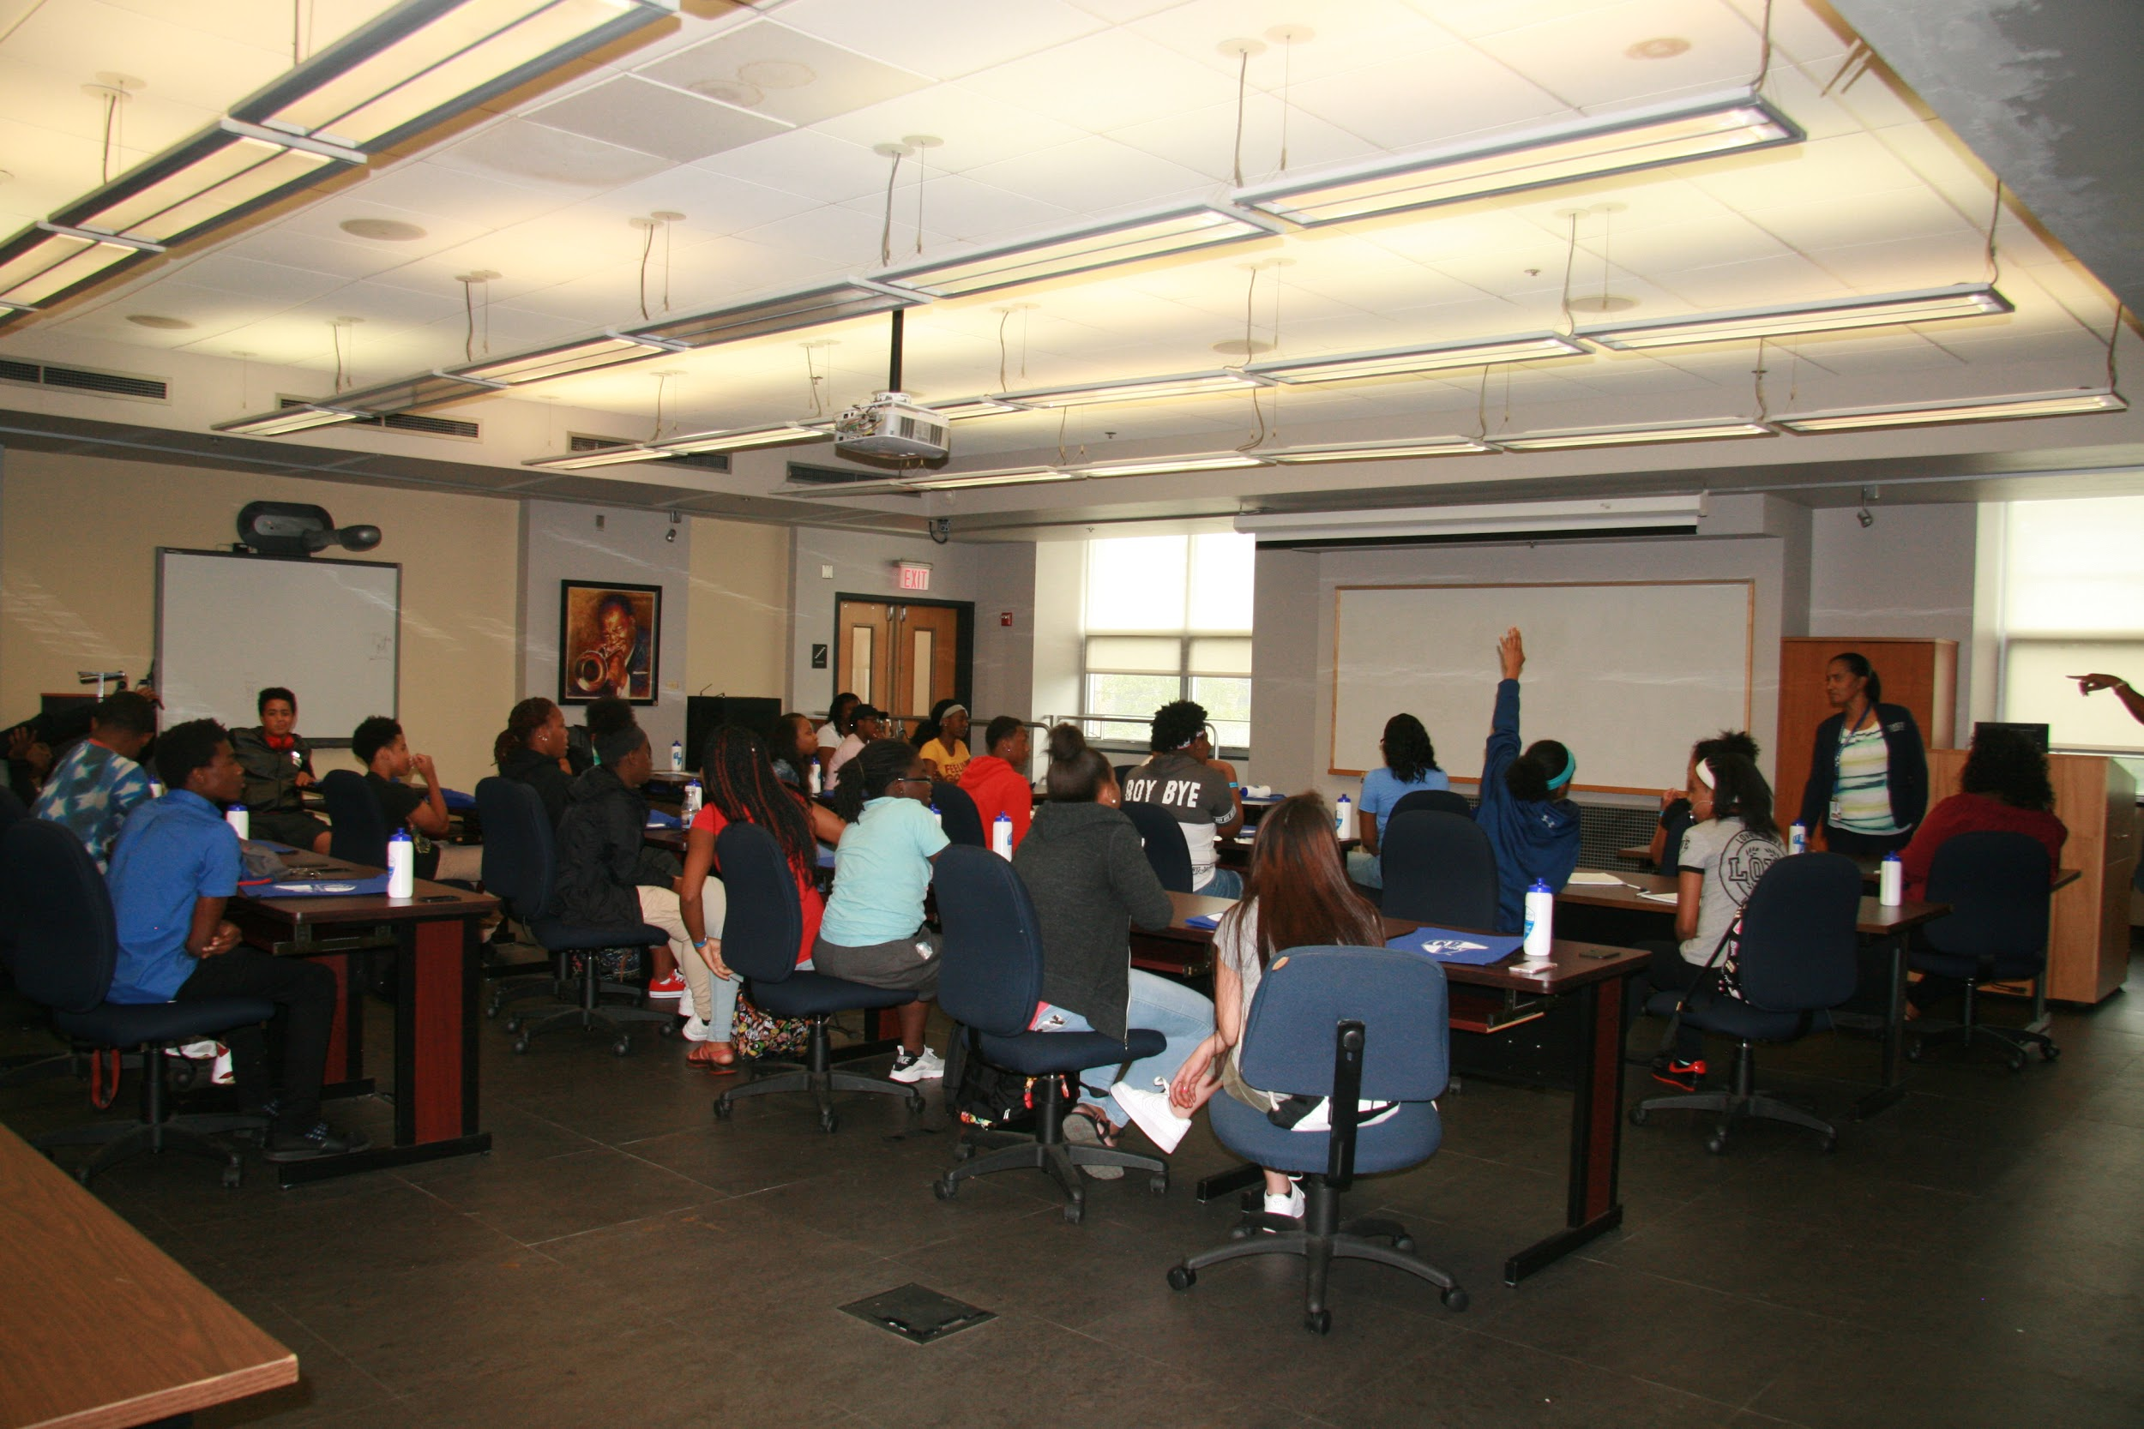
Our Mission is to equip the youth with the tools and skills needed to be successful in life, through leadership training, life skill building, tutoring, mentoring and career interest exploration, community service, college exploration, and academic success incentives.
In 2016 and 2017…
We were able to take a combined total of 67 youth and 16 parents on college exploration trips. We visited over 25 colleges and universities ranging from Columbia University in New York, Johns Hopkins University in Maryland, Temple University in Philadelphia to Allen University in South Carolina.
The Successes:
- All 16 Seniors that participated in the 2016 College Exploration trip graduated June 2017 and 6 out of 8 seniors from the 2017 College Exploration trip
- 9 out of 16 Seniors who participated in the 2016 trip are attending colleges and universities and 6 out of 8 seniors who participated in the 2017 college trip have applied and been accepted into colleges and universities
The Residual effects
- Out of 10 parents who participated in the 2016 trip 4 enrolled in college and 2 have completed their GED

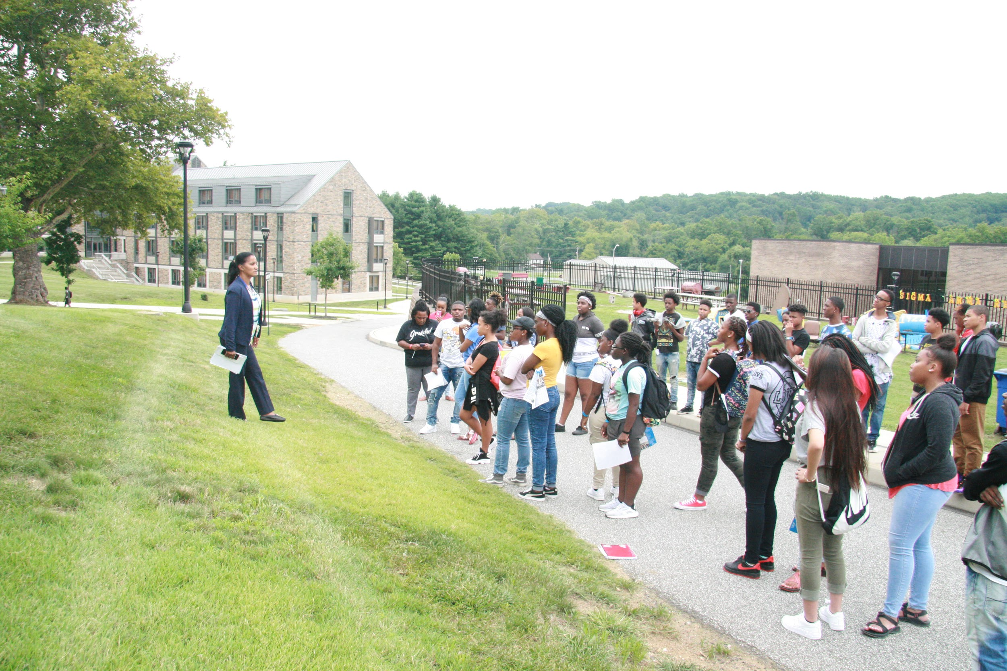
Objective: The objective of the College Exploration trip is to introduce High School students to college options that they may not have considered, or thought was possible. This experience will, for a lot of the parents and first-generation HS graduates, help establish a mindset of “I Can” and create a college-driven culture outside of school and inside the home. PCYM is striving to improve the HS graduation and College enrollment rates by showing youth living in the underserved communities of Asheville and Buncombe County, who otherwise would not be able to afford to explore institutions of higher education, that a college degree and upward mobility is possible.
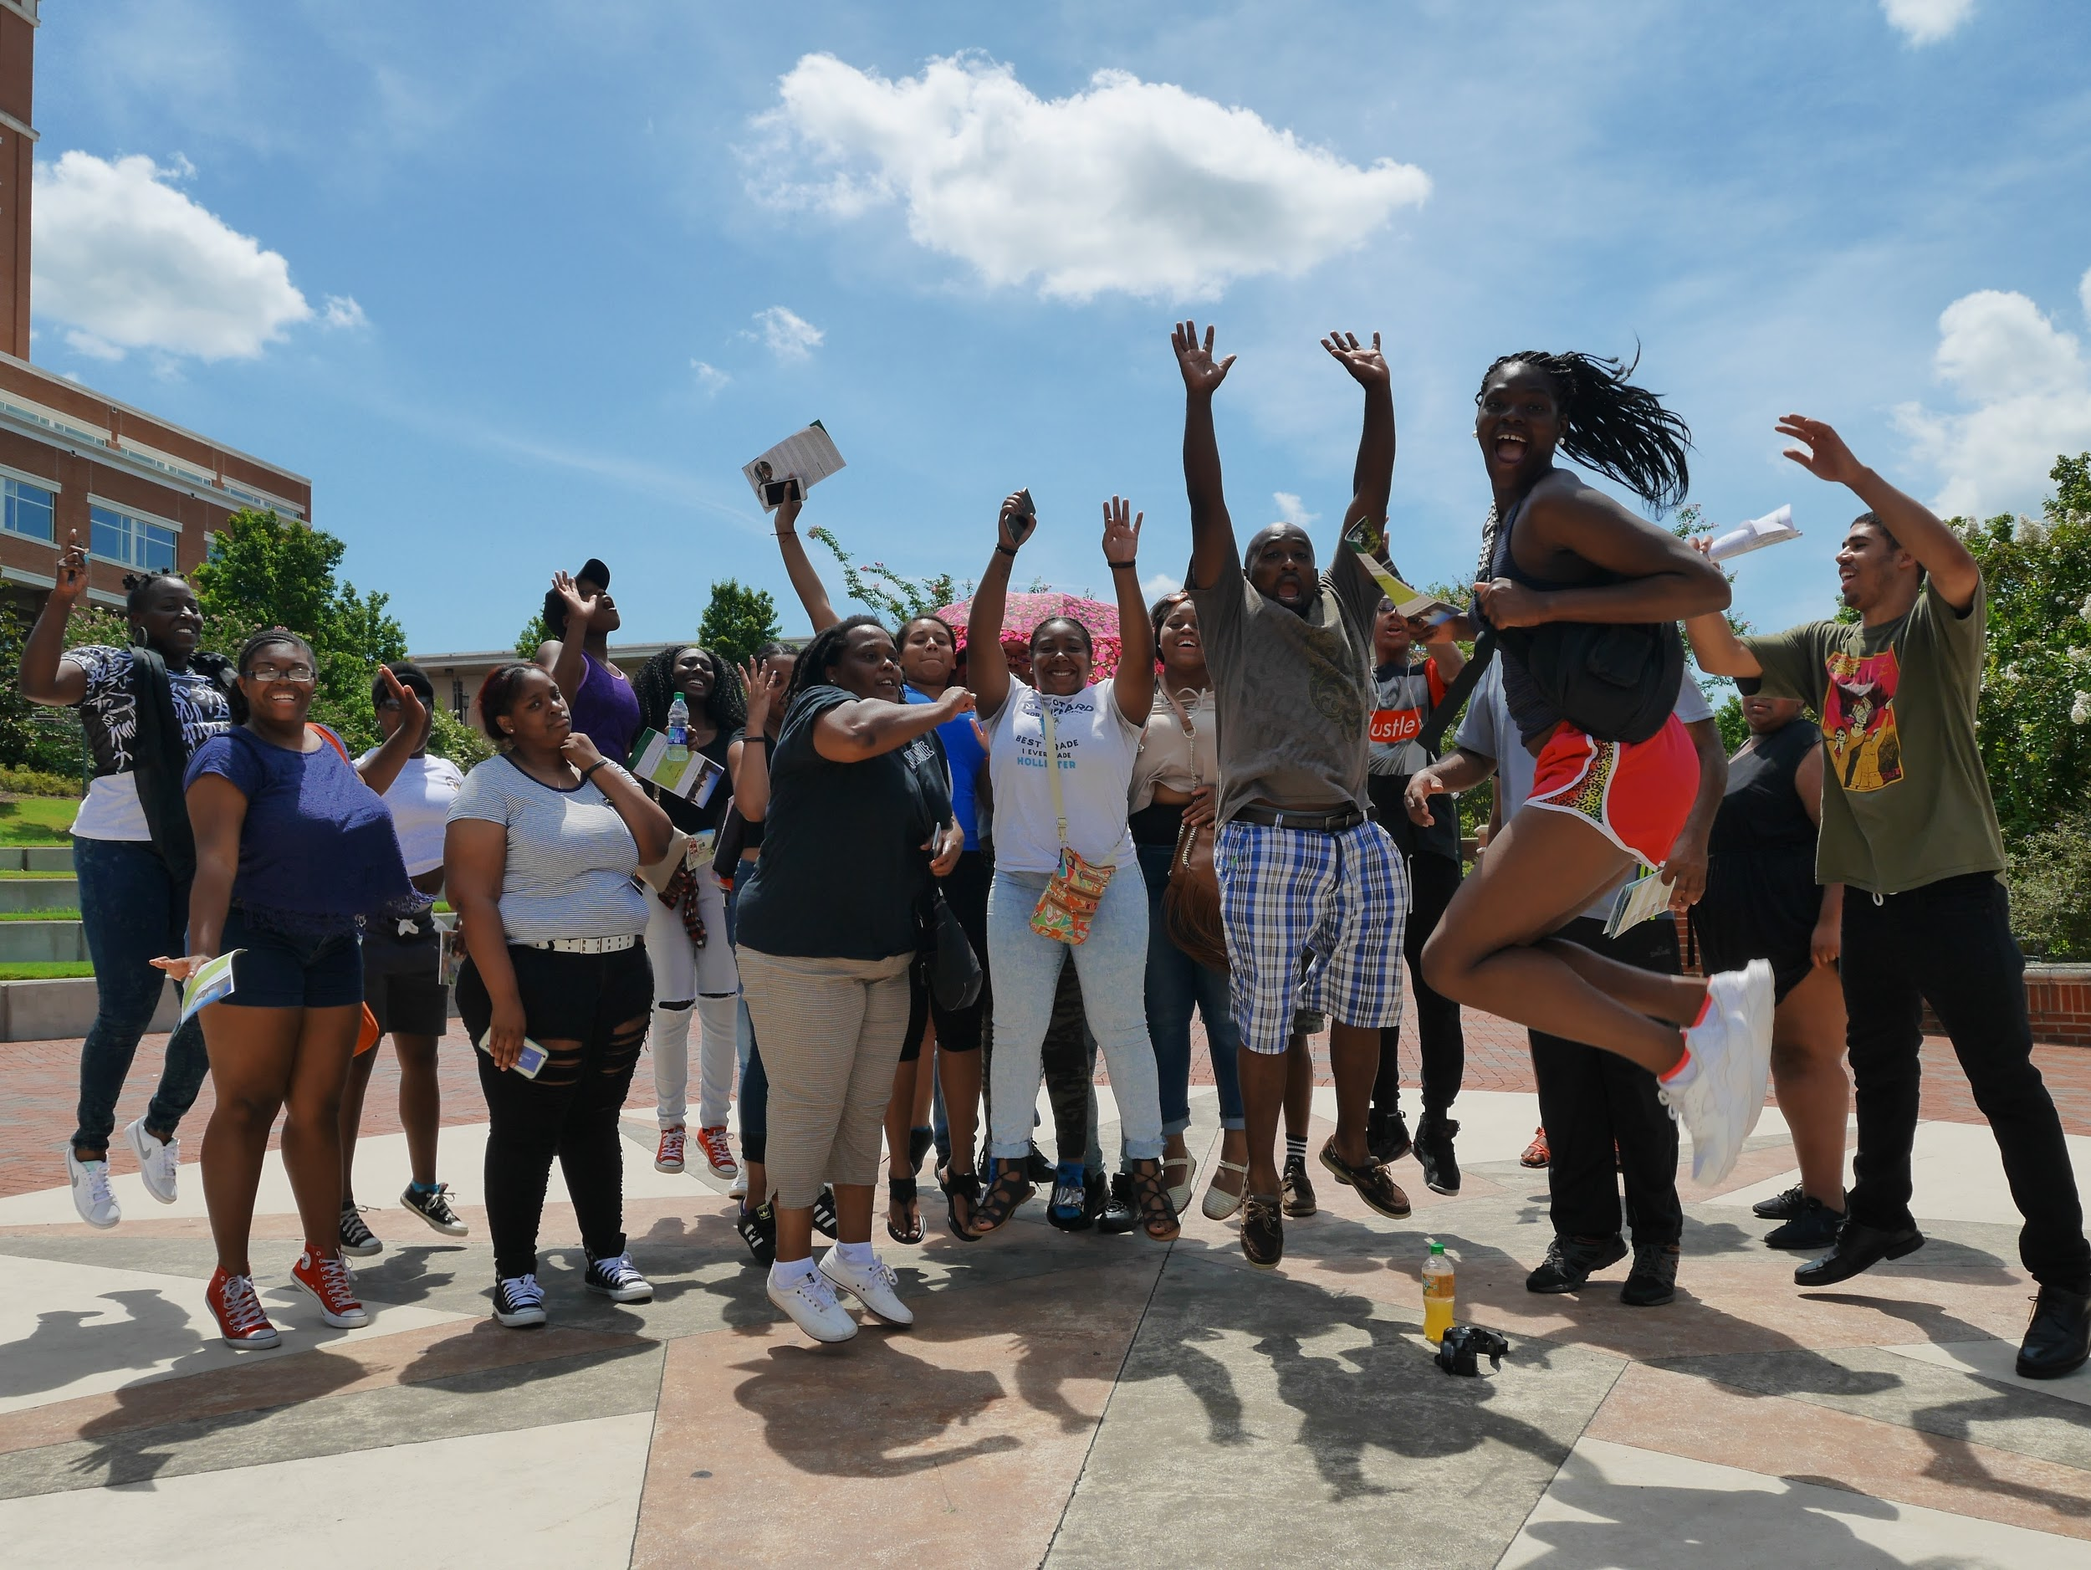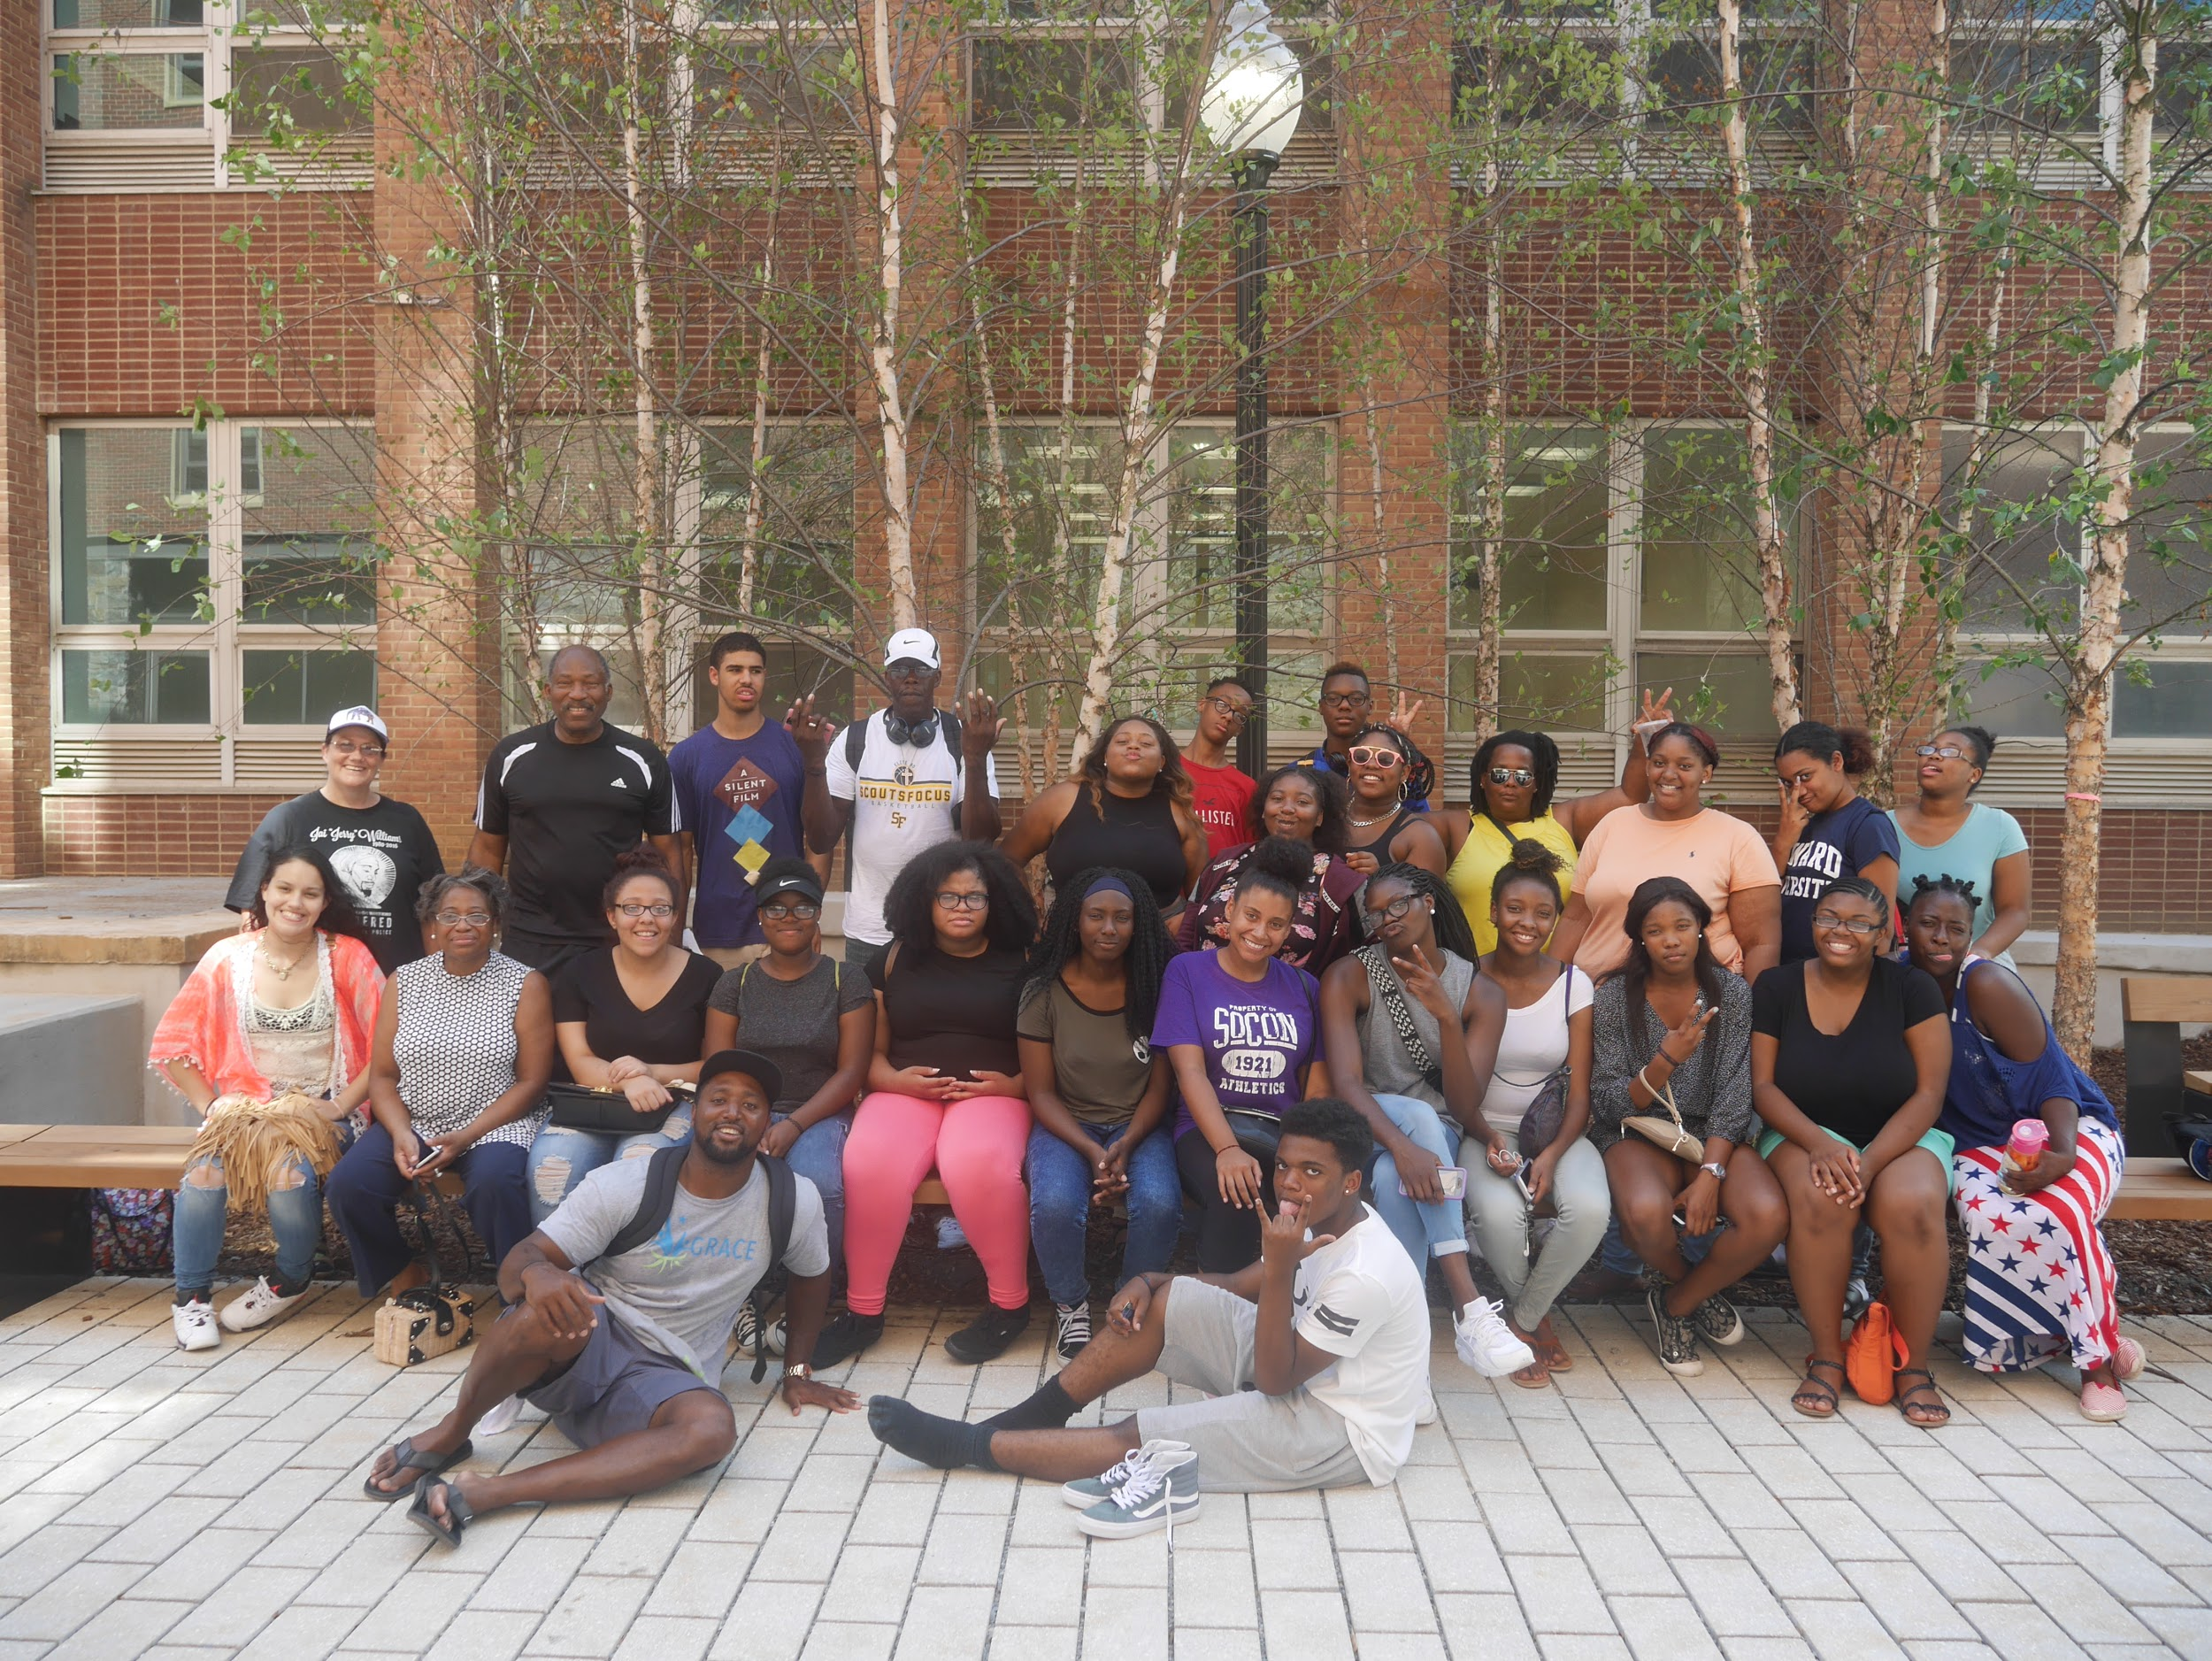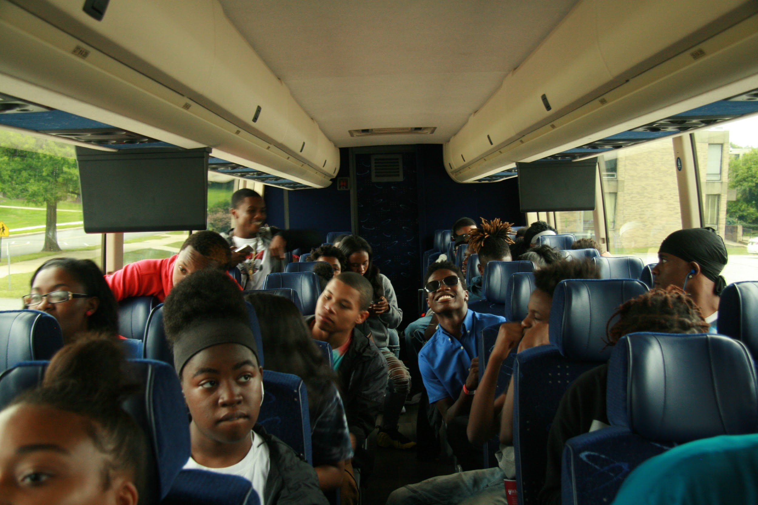
This year we will be going Southwest!
We will be visiting the following college and Universities:

- Fisk University Tour
- Meharry Medical College
- Alabama State University
- Tuskegee University
- Selma university
- Jackson State University
- Alcorn State University
- Southern University and A&M College
- Louisiana Southern University
- Xavier University of Louisiana
- Florida Agricultural and Mechanical University
- Florida State University

Below are details regarding benefits of this year’s sponsorship levels
All levels of sponsorship will go towards, including but not limited to, paying for travel, food, lodging, and educational recreation expenses for high school youth. The expenses of this trip averages out to $1500.00 per youth x 26= $39,000 total cost of the trip: Please submit sponsorships by July 6, 2018, Trip July 29th - Aug. 6th

- $5,000- Platinum Level: Special recognition at sponsored events, company’s name and logo on our organization’s website, and promotional materials such as signage at sponsored events, event T-shirts, social media pages, etc. In addition, you will also receive a Certificate of Recognition.

- $3,000 - Gold Medal: Special recognition at sponsored events, company’s name and logo on our organization’s website, event T-shirts, and you will also receive a Certificate of Recognition.

- $1,500 - Silver Medal: Certificate of Recognition and Company’s name and logo on promotional signage at sponsored events.

- $500-$1000 - Bronze Medal: Certificate of Recognition.

Please know that all amounts of contributions are welcomed. We thank you in advance for your consideration of donating to our organization. If your organization would like to participate in this year’s College Exploration Trip as a sponsor, please do not hesitate to contact me regarding your donation.

Sincerely,

Dewana Little
Co-Executive Director,
Positive Changes Y.M.
828-747-6097 cell
dewanallittle@gmail.com
Sponsorship Information

Name of Organization / Individual:_____________________________________________________________

Name of Represenative:____________________________________________________________________

Address:________________________________________________________________________________
Phone number:______________________________Email:________________________________________

Gift Amount: (Indicate the level of sponsorship and specify the amount)
__Level 1 $_______
__Level 2 $_______
__Level 3 $_______
__Level 4 $_______
__Other:___________________

Payment Methods

Please make all checks payable to: Eagle Market Street Development: FOR: Positive Changes Youth Ministries.
PayPal Accepted: https://www.paypal.com/cgi-bin/webscr?cmd=_s-xclick&hosted_button_id=D5UK6UPY8RJ68 or Make checks payable to: EMSDC - Community Benefit Partner, in the memo section it should state for Positive Changes.

Enter in the following information if you’re using a credit card to make your donation or feel free to call to make other arrangements for payments.

Credit Card Number:__________________________________________________________

Expiration Date:______________________ CVV (card verification value):________________

Card holder’s name: __________________________________________________________

Signature:____________________________________ Date:__________________________

Thank you for your contribution.

